1. Search in Google “Github Tracelab”
2. 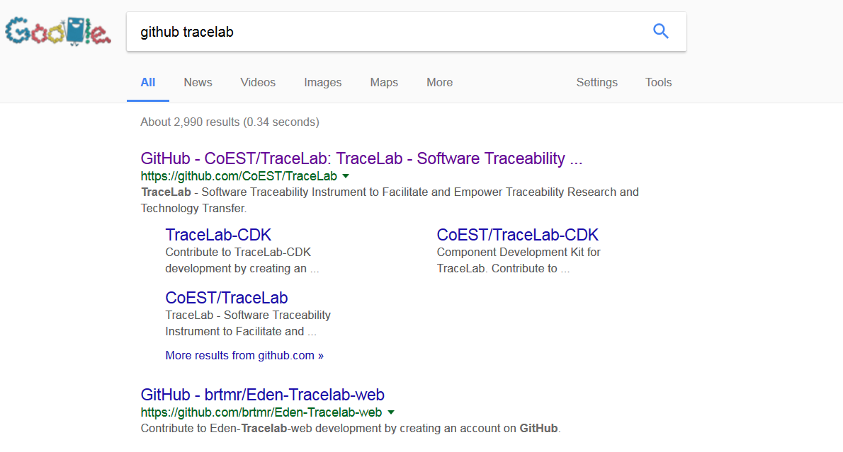Select the option in purple “GitHub – CoEST/TraceLab….”
3. 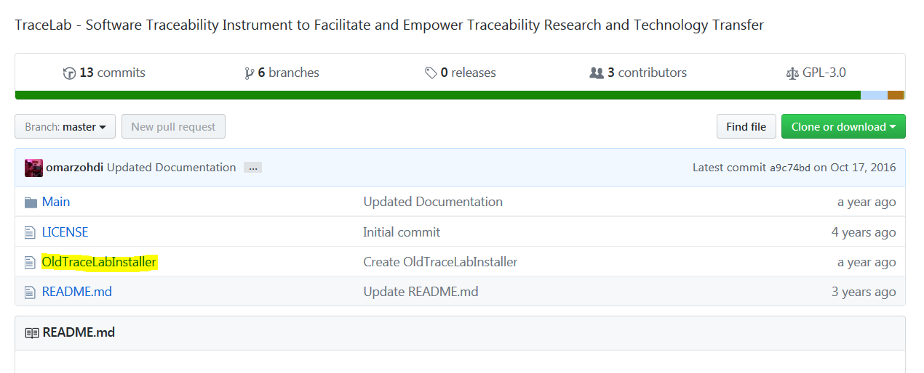Scroll down to the files and select “OldTraceLabInstaller” (in yellow)
4. 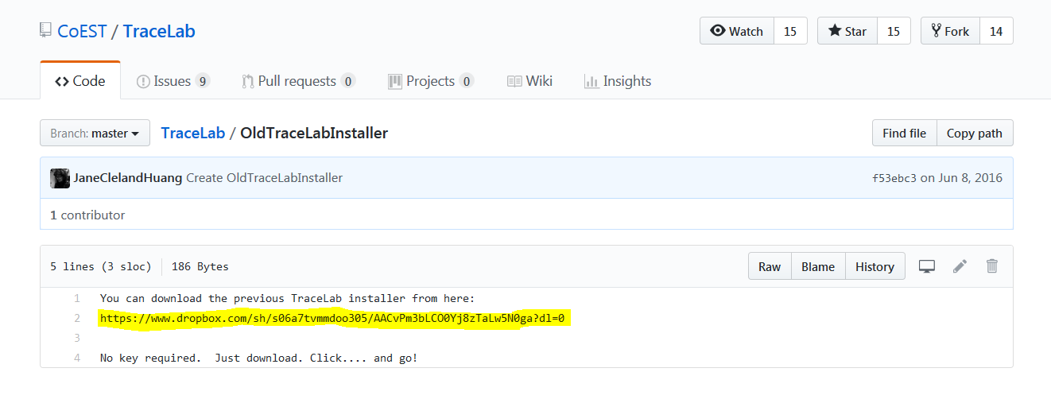Open up the link located on the third line (in yellow)
5. 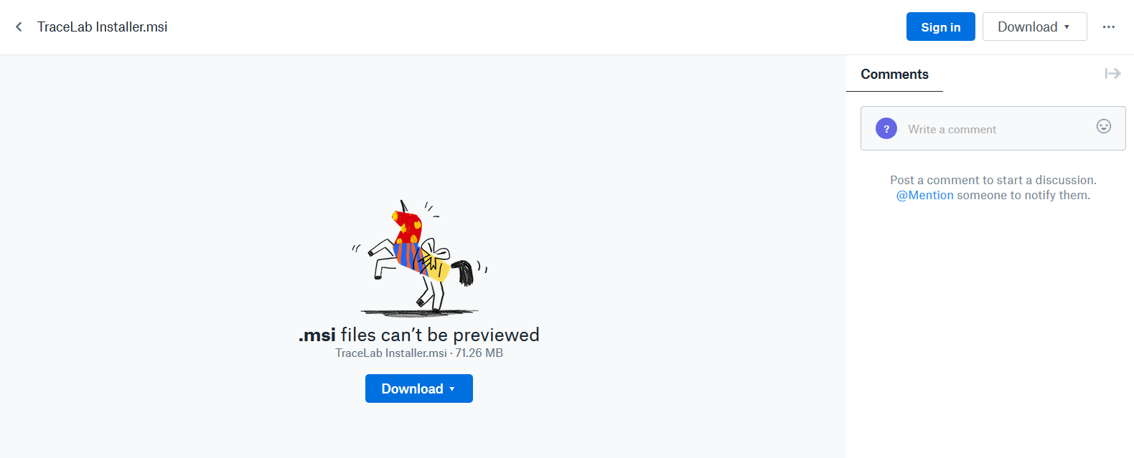Click on download in the Dropbox page, and wait for the file to be downloaded
6. After it is done, open up the download wizard and follow the instructions
7. TraceLab is now installed

